- Dashboard
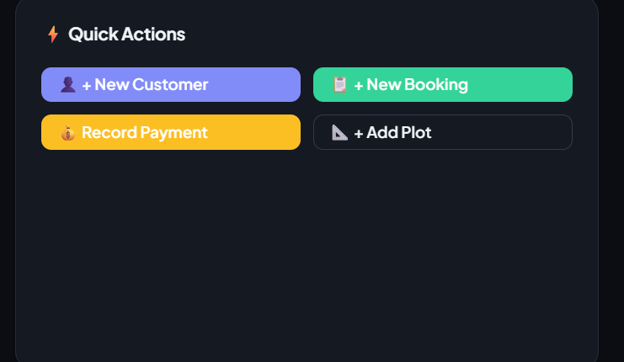
Yaha pe aur bhi quick actions add krne chye like add offices, expenses

Means ??
- Customers
Ye wo customer he jo leads k through aaya uski direct profile ban ghi aur uska koi nominee add nhi howa
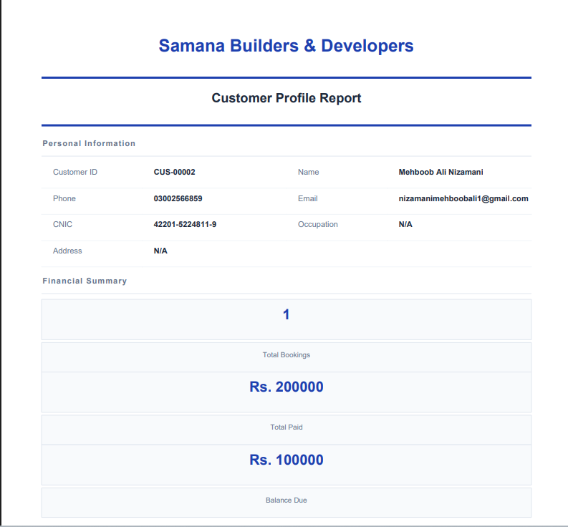
Edit pe click kr k uski nominee information add ki link ye pdf me bilkul sada he logo etc kuch nhi he 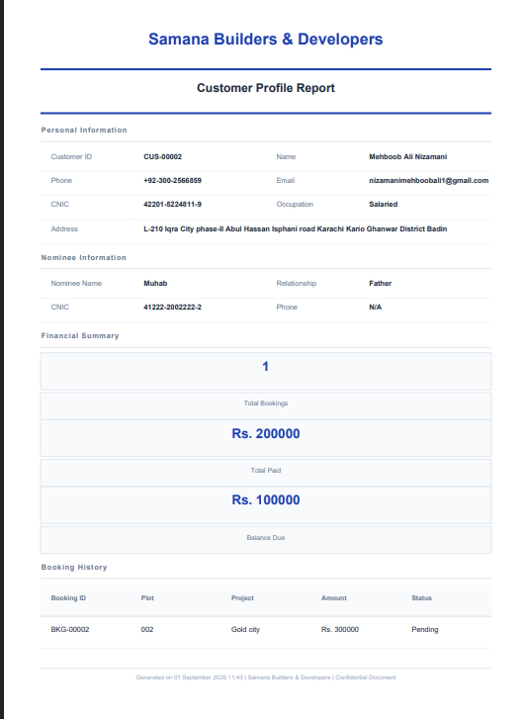
Customer portal me agr customer ko nominee information show ki jae tu best he
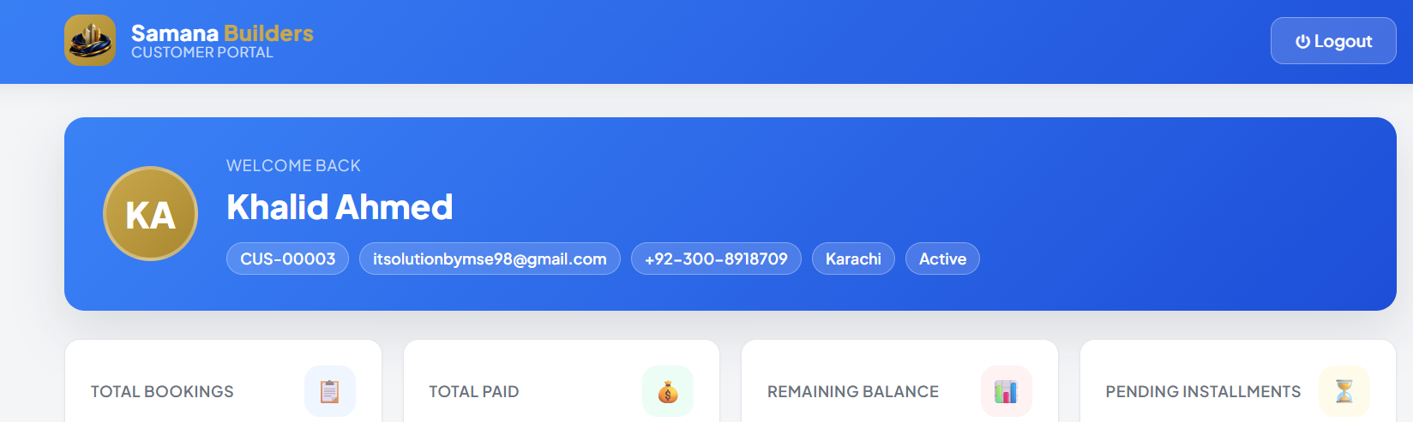

- Properties
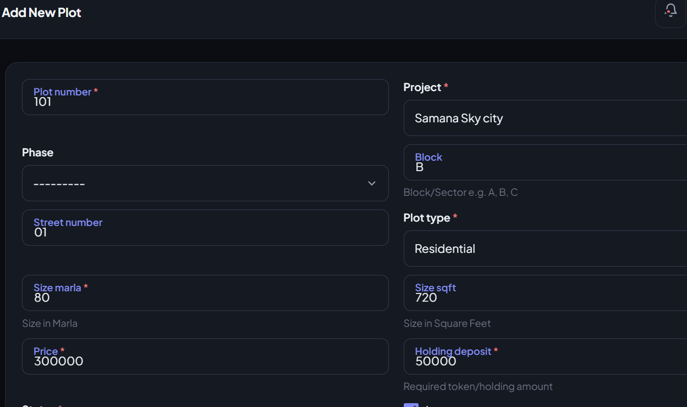
Correct Size in square yards aur phase add krne ka option kam nhi kr rha he aur jo numerical prices etc hain for example ise format me ho 2,776,000
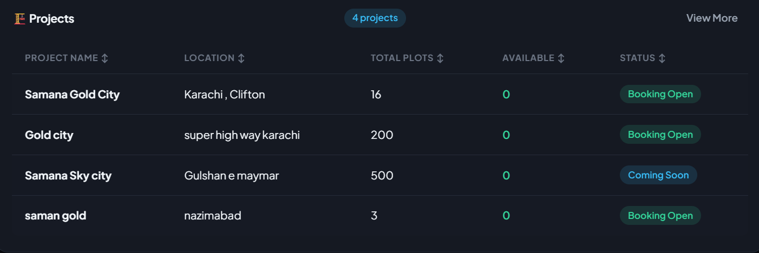
Projects me edit delete ka option hona chye ,
4. Booking
ishi plot ki price for example 3 lacs he and deposit 50000 ha tu ishi booking k time bhi wohi amount honi chye neche dekho mani yehi plot becha he 5 lacs me aur advance payment li he 3 lacs

aik aur example he ye plot 2 lacs ka tha hamne 1.5 lacs ma kese bech dyea 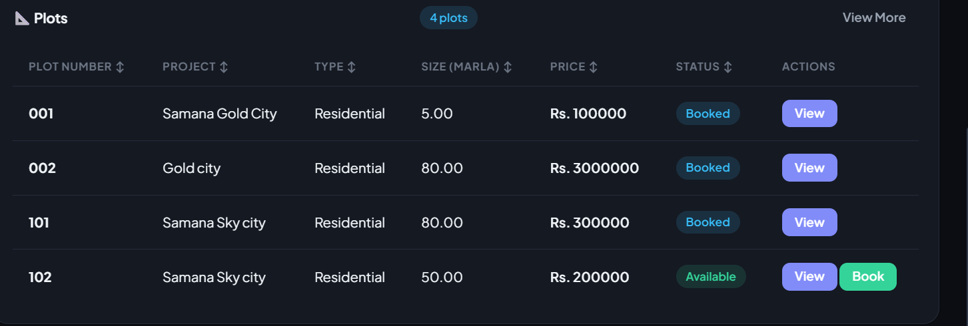


ham ne jab form fill kr k plot add kia tu uska deposit holding price add ki likin yaha pe plot koi details show nhi ho rhe hain jesa k advance payment ktini ho he etc
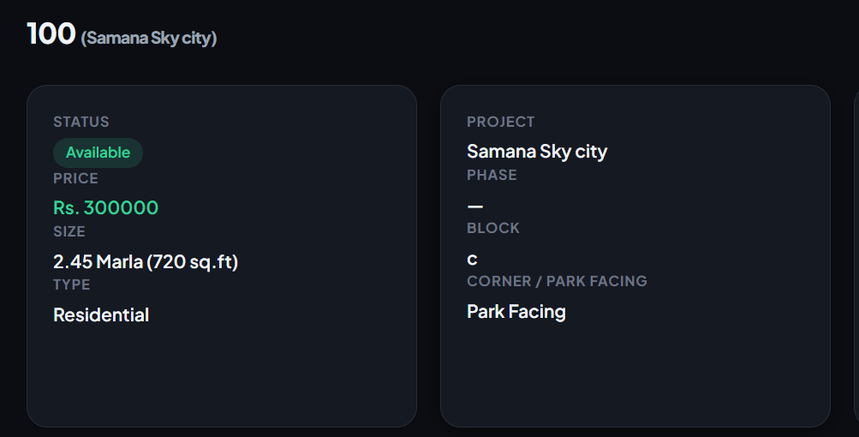
iski booking cancel bhi nhi ho rhi he

Booking edit nhi ho rhi he aur edit krne k time pe wo plot no hi show nhi ho rha he
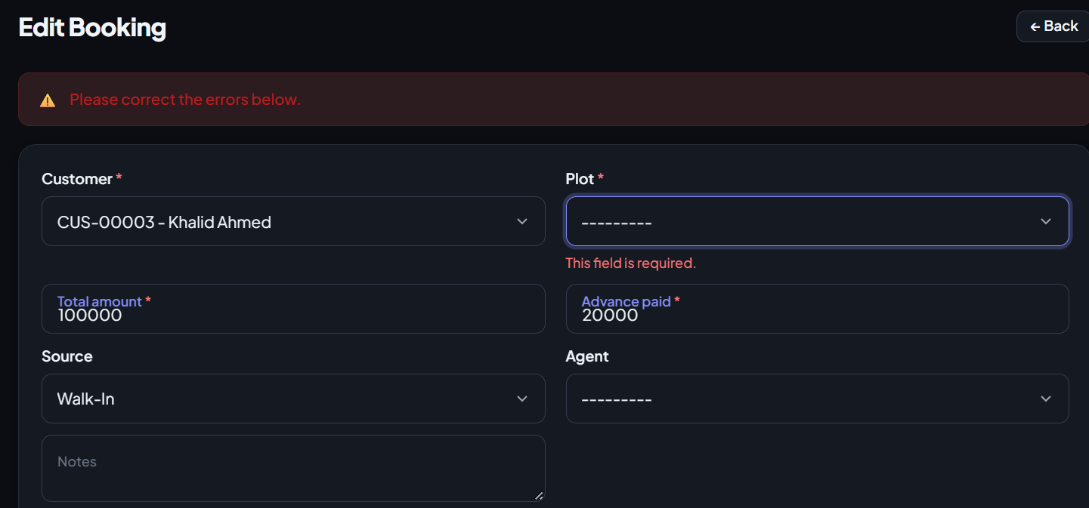
Isme bande ne 0 advance payment ki phir bhi booking confirm show ho rhi he iski confirm honi hi nhi chye restriction ho.
iski receipt bhi simple he
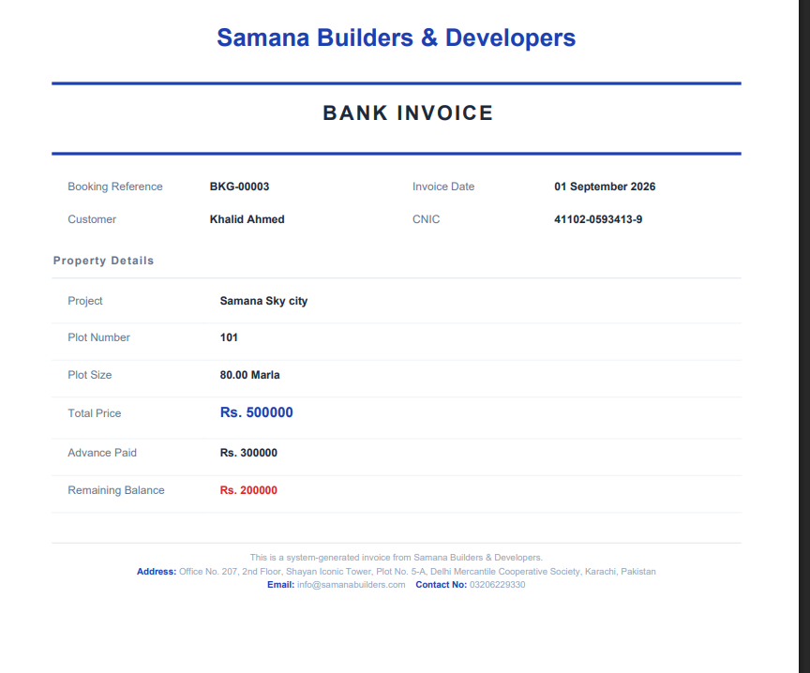
5.. payments
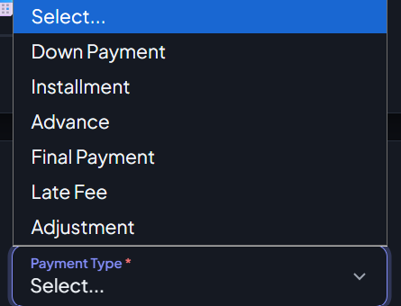
Developments charges , lease charges , etc ye total plot k charges me include nhi hote hain
Receipt RCP-FY26-27/00002 - Rs. 50000 - Samana Builders
complete receipt abhi bhi whatsapp pe share nhi ho rhi he

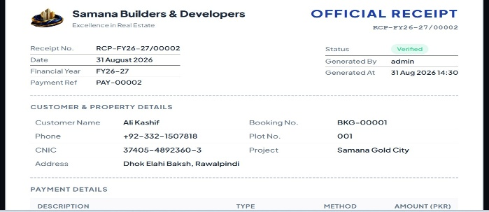
isme logo show ho rha he

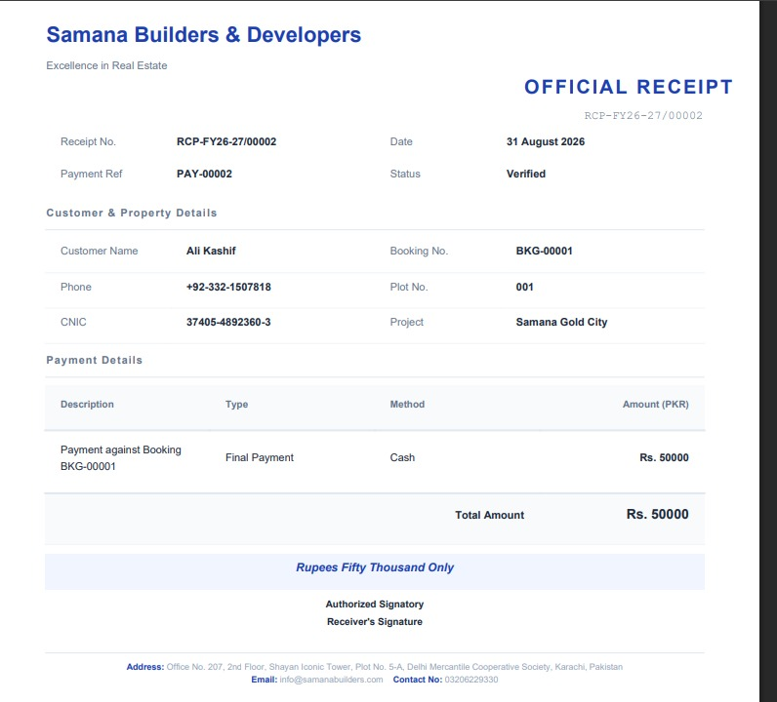
PDF ME download krne k bad asi ho jati he aur print pe click krte hain tu 2 pages pe aati he aur sath different icons print ho rhe hote hain, Share via Email ye button bhi kam nhi kr rha he
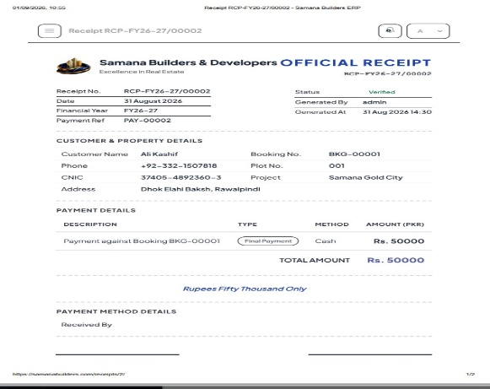

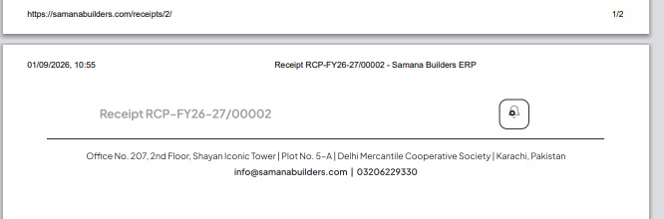
6.. Expenses
Expense Category : Construction Material , Labour / Wages , Marketing , Office Expense , Utilities , Transport , Legal / Documentation , Maintenance , Miscellaneous
7. Financial Reports
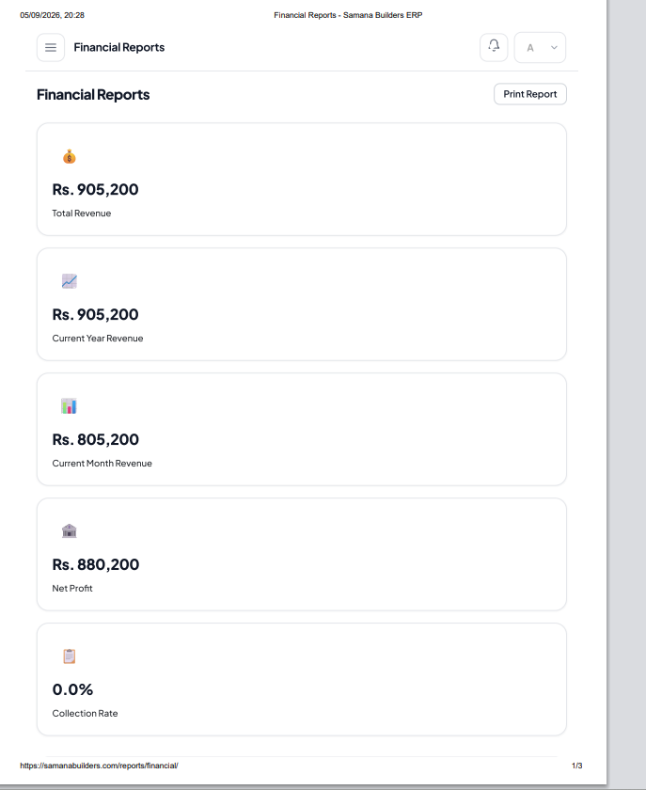
Proper report ban jae tables me aur description bhi add honi chye

8. refund
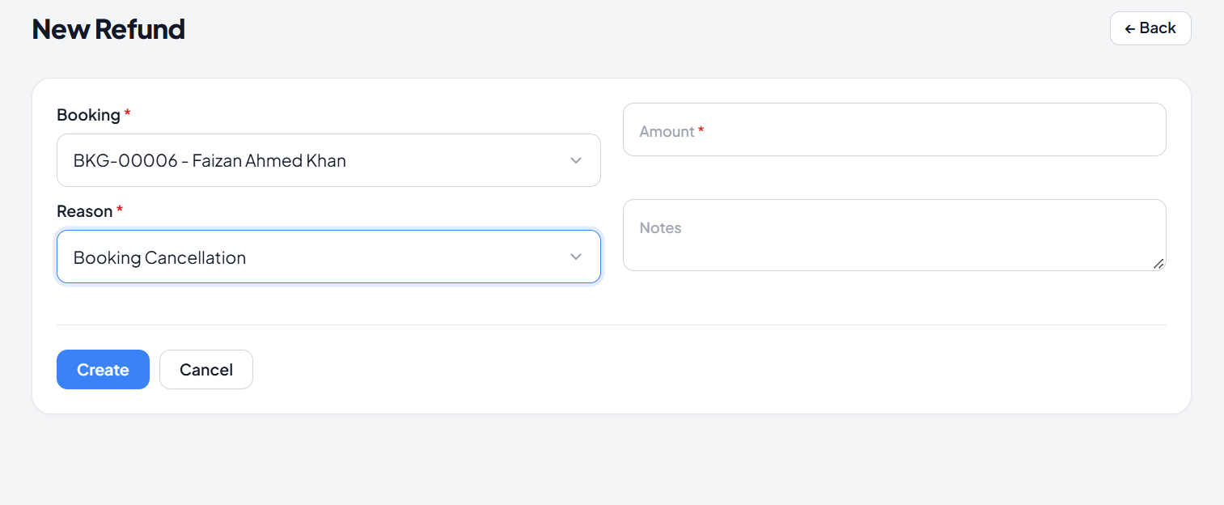
Add , project name , Unit/Plot: 80 Sq. Yds, Total Paid: , Already Refunded: Rs. 0
Available for Refund: Rs. 450,000 (maximum) , add refund percentage , Refund Method ( cash etc ) , refund date , Refund Status ( Pending Approval , Approved , Processed , Rejected ), Upload Supporting Document( Cancellation request , Customer application , Payment receipt )

Important : note Rs. 699800 ( 6.9 lacs, millon , billon ki description ho etc )

9. sales report
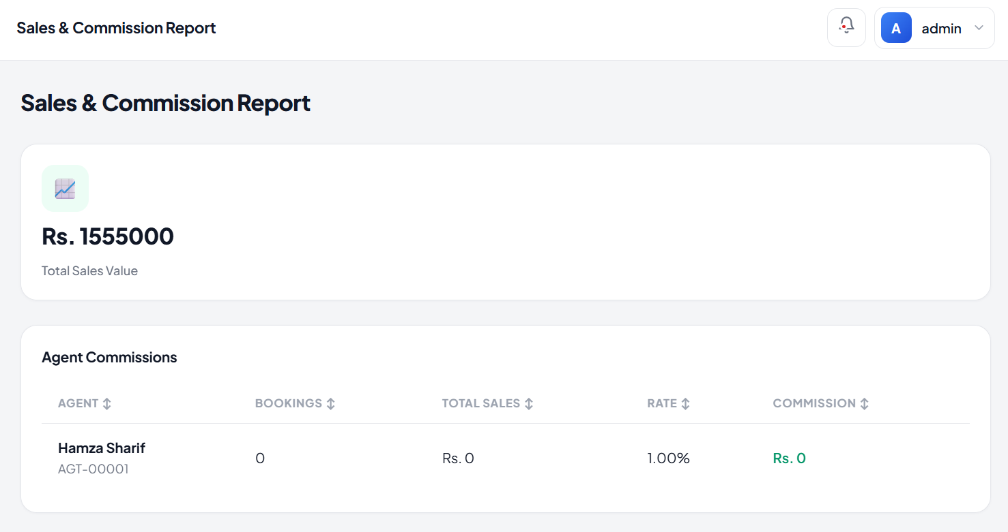
Sales report bhi print honi chye
10. milestone
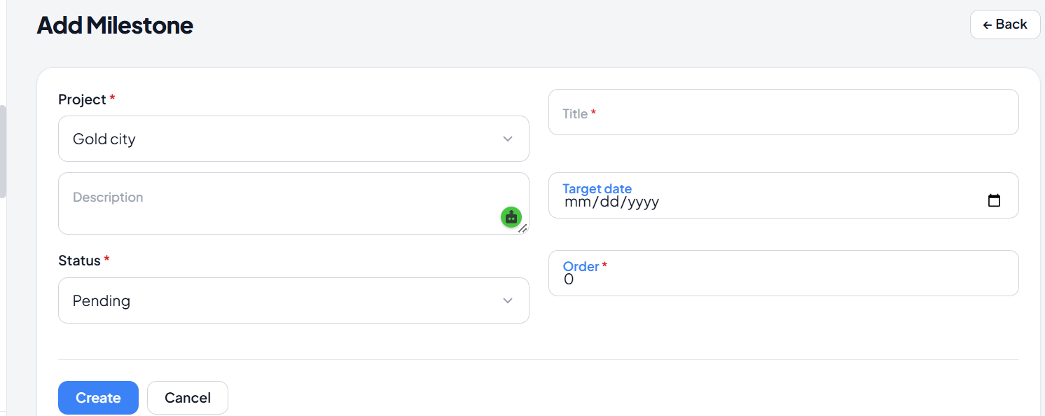
Add start date , Milestone Type ( Construction , Payment , Development , Documentation , Handover, Other) , update (Completion % + date )
11. Financial leder
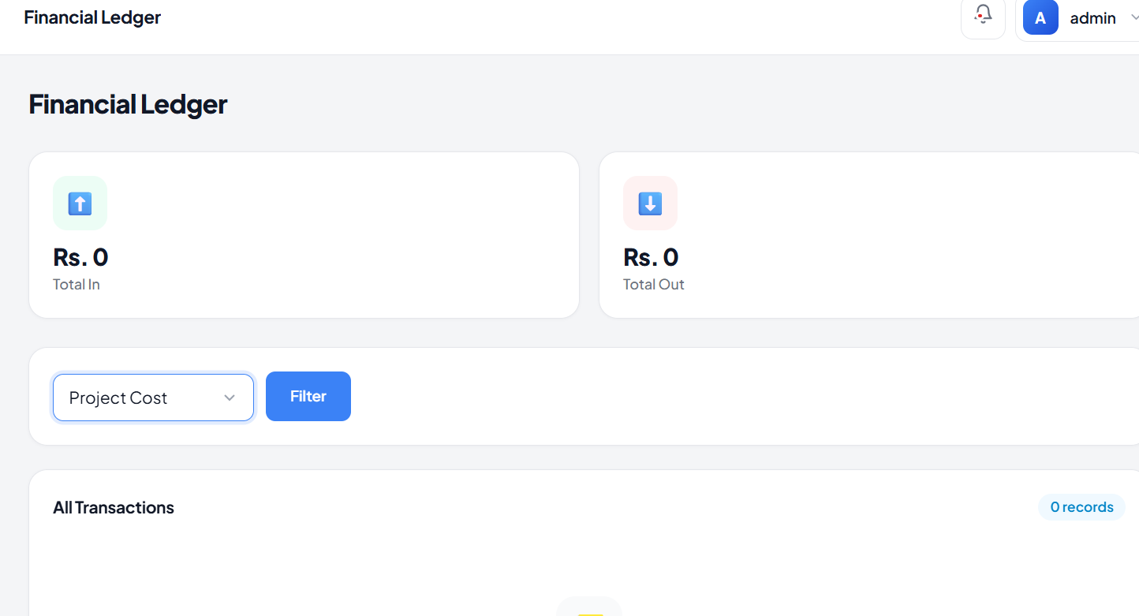

Financial Ledger ko sirf transactions ki list ke bajaye proper accounting module banana chahiye, jahan Total Inflow, Total Outflow, Net Balance aur Total Transactions clearly show hon. Ledger mein Date, Project, Transaction Type aur Party ke filters ke saath search aur transaction details ka option ho. Customer Payments, Expenses, Refunds, Adjustments aur Other Income automatically consolidate hon aur har transaction ke baad Running Balance calculate ho. Saath hi Opening Balance, Closing Balance aur Excel/PDF Export ki facility hon, taake company ki complete financial movement ek hi screen par accurately track aur manage ki ja sake.
12. add expense 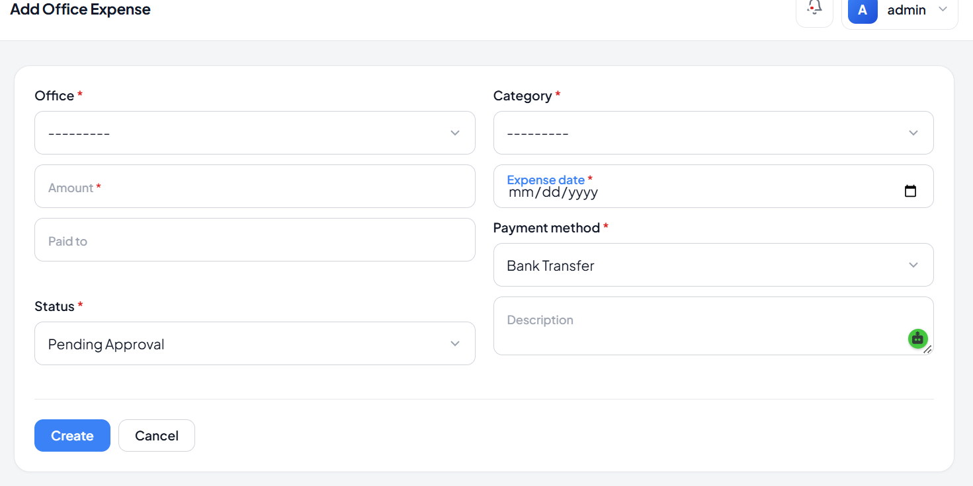
Payment Reference / Cheque No. aur Receipt/Bill Attachment bhi add hone chahiye. Status mein Pending Approval, Approved, Paid, Rejected rakhein, aur approval ke baad hi expense ko final ledger mein post karein.
Office Expense Report
Print propoer hona chye
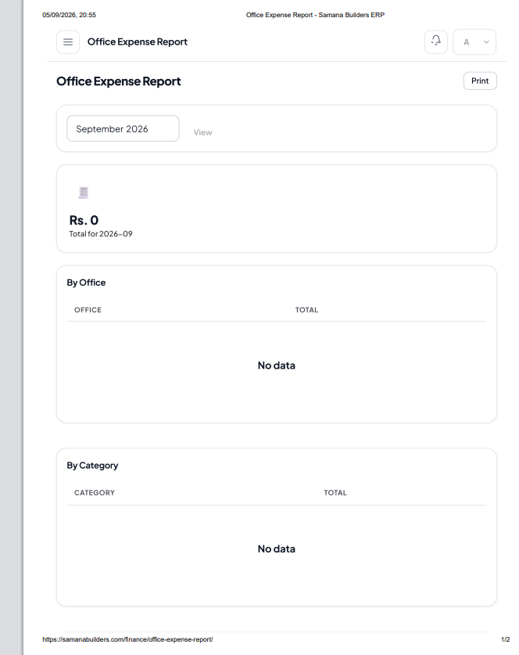

13 . Project cost
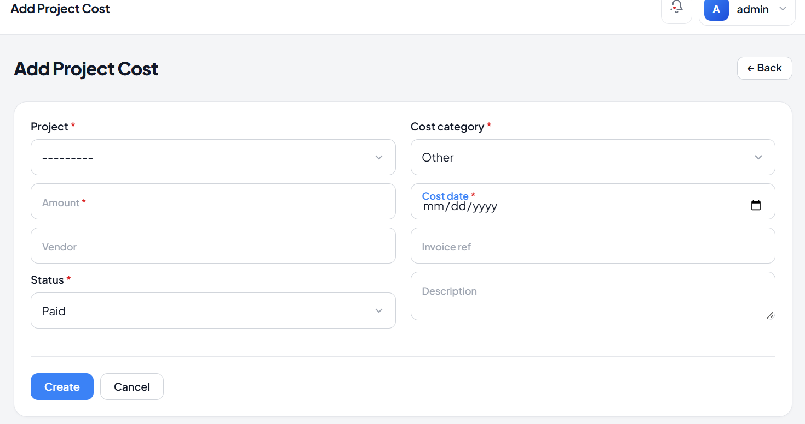
Project Costs ko professional aur accounting-focused banana chahiye, jahan Total Project Cost, Paid Cost, Pending Cost aur Approved Cost clearly show hon aur Project, Cost Category, Vendor/Contractor, Status aur Date ke filters available hon. Cost categories mein Material, Labour, Contractor, Transportation, Equipment, Development aur Other hon, jabke table mein Date, Cost ID, Project, Category, Description, Vendor, Amount, Status, Payment Status aur Actions show hon. Cost ka workflow Draft → Approved → Paid ho, aur sirf Paid Costs actual project cost aur budget calculation mein count hon. Har project ke liye Budget vs Actual Cost aur Remaining Budget bhi clearly display ho. Project Cost form mein Contractor/Vendor selection ke saath separate Contractor/Vendor Master maintain kiya jaye, jisme Contractor/Vendor Name, Company Name, Contact Person, Phone, Email, CNIC/NTN, Address, Bank Name, Account Title, IBAN/Account Number, Contract/PO Number, Contract Date aur Work/Service Description ki complete details hon. Project Cost mein Bill/Invoice No., Bill Date, Payment Method, Payment Reference, Due Date aur Bill/Receipt Attachment bhi available hon. Contractor ko select karte hi uski saved company details automatically populate ho jayein, taake duplicate data entry na ho aur contractor-wise cost, outstanding payments, total paid amount aur project-wise expenses easily track kiye ja saken. View, Edit, Approve, Mark as Paid, Excel/PDF Export options bhi hon, aur Paid Project Costs automatically Financial Ledger mein reflect hon, jabke Project Costs, General Expenses aur Office Expenses accounting mein clearly separate rahen.

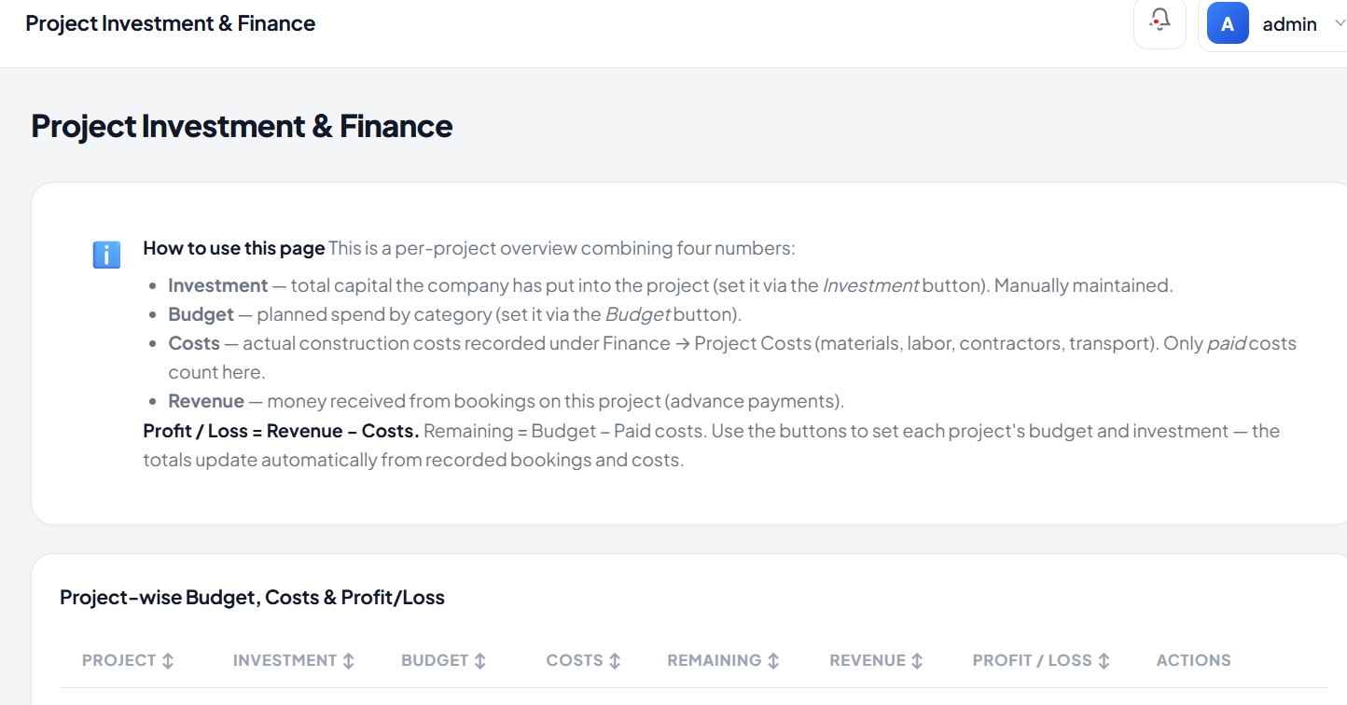
Add print button

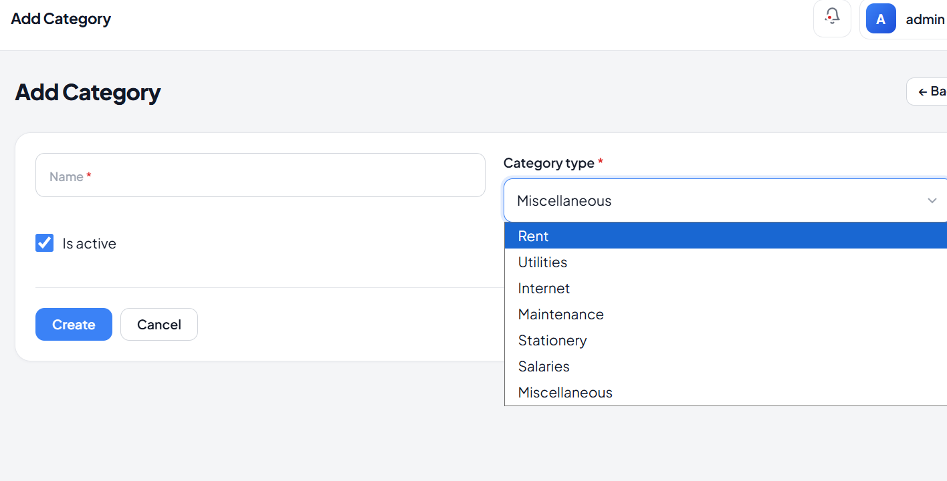
Category konsi ? clear kro

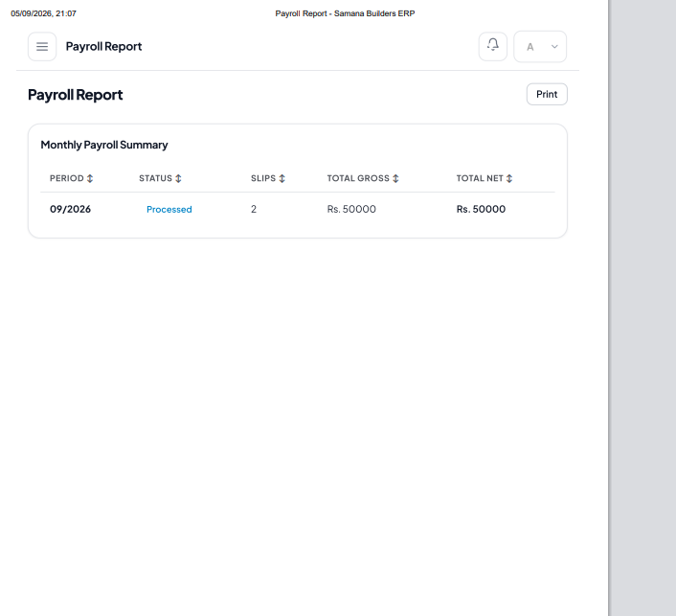
Print sahi se ho

